***Online report:*** *a visually engaging summary of key findings (sits above the current report online).* *The aim is to encourage researchers to drill down into the details, formulate their own research questions and make use of the public available survey data.*

* Introduction to the People and Nature survey
  + Intended audience
  + Where to find the data and more analysis
* Feelings about nature
  + Very high percentages of people value and enjoy nature, but somewhat lower percentage feel part of nature.
* green space visits and Covid-19
  + Annual average prop visited in last 14 days
    - Perhaps hard to feel part of nature, if not visiting …
  + Overall trend for visits (and uncertainty around this).
  + Annual trend likely driven by Covid-19 restrictions and concerns.
  + But, people feeling and being engaging more with the environment during the pandemic too.
  + Other notable findings:
    - Differences in number of visits across the ages groups
    - Many more people not visiting, than visiting everyday
* *(But inequality)* perceptions of green space
  + People with higher household incomes more likely to perceive improvement in quality over last 5 years
* Clearly many people value nature and enjoy visiting natural spaces. So, what are people doing to protect nature?
  + Large proportions of people are not frequently engaging in high environmental impact activities (fly and commuting by car). Eating meat remains a high impact activity that many people engage in regularly.

**Disclaimer:** This is a personal project using publicly available data. Natural England were not involved in the project at any stage. I worked on this project prior to starting employment with Natural England. Any, and all, mistakes in the analysis, interpretation or presentation of the data were my own.

**The project in brief:**  in this project I explore what a data-driven, visual story which communicates the research opportunities created by an open dataset could look like. I use the People and Nature Survey dataset, published by Natural England, as the basis for a story.

**The project in more detail:**

|  |  |  |  |  |
| --- | --- | --- | --- | --- |
| **Format** |  | **Audience** |  | **Objectives** |
|  |  |  |  |  |
| A data-driven story for inclusion on my portfolio webpage or Behance. |  | Publishers of open data interested in increasing researcher engagement.  *Likely to be viewing online on a desktop (rather than mobile).* |  | * Demonstrate the opportunities for data-driven story to open data publishers. * Develop my skills in data-driven storytelling. |

**A bit more about the format:** This piece of my portfolio takes the form of a data story incorporating text and visuals. The text around the visuals is (I think) the minimal needed to tell the story and connect the visuals. The text offers a skeleton which could be iteratively develop in collaboration with people who hold more expertise in the subject area than I do.

**The process:**

I identified the opportunity to use data-driven visual stories to communicate research opportunities created by open datasets. The idea emerged to me through reflection on my career which has included work as an academic researcher, and work within a team which published open dataset.

To explore the what such a story might look like I focused on the [People and Nature Survey](https://www.gov.uk/government/statistics/the-people-and-nature-survey-for-england-data-and-publications-from-adults-survey-year-1-april-2020-march-2021-official-statistics/the-people-and-nature-survey-for-england-data-and-publications-from-adults-survey-year-1-april-2020-march-2021-official-statistics-main-finding) dataset. I reviewed the published summary of the main findings of the survey, for the period aApr. 2020 – Mar. 2021 inclusive. This is an online report which presents a wide range of fairly detailed statistical results. Some of these results were presented with accompanying visualisations. I took these visualised results to be the headlines, as the team analysing the survey had gone to additional effort to produce visualisations. Focusing on these headline findings I analysed the raw survey data (which was publicly available). Then through multiple iterations, I developed and refined the text and visualisations that make up the data story presented below.

**Tools used:** R for data cleaning *(Tidyverse)*, statistical analysisand creating data visualisations *(ggplot2).* Microsoft Excel for producing tables. Affinity Designer, Affinity Publisher and Inkscape for creating and editing data visualisations.

# Communicating the research opportunities created by an open dataset

Dr. Christopher Martin (24th January 2022)

Researchers are faced with an overwhelming wealth of data. This includes Government statistics and other data, openly published academic data, and the data researchers collect themselves. Over the last decade, or more, there has been a huge growth in the amount of this public available open data. But the full value of this open data is yet to be realised.

Many open data publishers have an opportunity to promote greater use of their datasets, and to engage with a wider audience of potential data users. By doing so they could enable more researchers to use their datasets, which in turn would drive innovation and create associated social, environmental, and economic benefits. Sharing data-driven, visual stories which communicate the research opportunities created by an open dataset could help data publishers improve engagement with research communities.

In this article I explore what such a data-driven, visual story could look like. To do this I need an example dataset. I use a dataset created by Natural England[1] (an environmental public body in the UK), which includes people’s responses to the [People and Nature Survey](https://www.gov.uk/government/statistics/the-people-and-nature-survey-for-england-data-and-publications-from-adults-survey-year-1-april-2020-march-2021-official-statistics/the-people-and-nature-survey-for-england-data-and-publications-from-adults-survey-year-1-april-2020-march-2021-official-statistics-main-finding). More details about the survey methodology and results, and the survey data itself can be found [here](https://www.gov.uk/government/collections/people-and-nature-survey-for-england).

I have not chosen this dataset because there are a limited number of researchers engage with it, or that there is any other form of problem or issue. I do not know if Natural England are looking to increase researchers’ use of the dataset or not. I chose the dataset as I recently became familiar with it, as part of apply for a job at Natural England.

## An illustrative example: a data-driven, visual story about the research opportunities created by the People and Nature Survey.

**Disclaimer:** This is a personal project using publicly available data. Natural England were not involved in the project at any stage. I worked on this project prior to starting employment with Natural England. Any, and all, mistakes in the analysis, interpretation or presentation of the data were my own.

Since April 2020, Natural England has been running the [People and Nature Survey](https://www.gov.uk/government/collections/people-and-nature-survey-for-england). This survey is participated in by a representative sample of England’s population. Up to 25,000 people participate year by completing the survey online. The survey gathers evidence on how people use green spaces, their attitudes towards nature, and how they try to protect the natural environment. In this article I highlight opportunities for researchers to: explore this survey data; come up with new research questions; and, to use the data in novel, high impact research studies.

To give some sense of possibilities for researchers to use the People and Nature survey data, I explore some of the key survey results. Specifically, results for the between [April 2020 and March 2021](https://www.gov.uk/government/statistics/the-people-and-nature-survey-for-england-data-and-publications-from-adults-survey-year-1-april-2020-march-2021-official-statistics) (inclusive). I focus on how often people were visiting green spaces over this period, which of course was shaped by the Covid-19 pandemic and the associated restrictions. I then turn to highlight some of the other data collected by the survey which researchers might use to better understand green space visiting behaviour. In addition to highlighting research opportunities, I hope that this article offers a glimpse into how people connected with, and thought about nature, early in the Covid-19 pandemic.

### Visit data

Averaged over the year (from April 2020 to March 2021), the survey results show that typically 29% will not have visited a green space in the last 14 days. While in contrast only 7% will have visited a green space 14 times or more in the last 14 days (something we might think about as approximating visiting every day).

Focussing in on the question of whether survey participants have made a visit to green space in the last 14 days, it is interesting to see how this varies from month to month. So, the potential impacts of Covid-19 restrictions, and potential seasonal affects, come into view. In the figure below, an increase in the percentage of people who had visited in the last 14 days can between April and August 2020. This of course coincides with the relaxation of Covid-19 restrictions after the first lockdown. The percentages do not sum to 100% as, for simplicity, “don’t know” and “prefer not to say” survey responses are not shown.

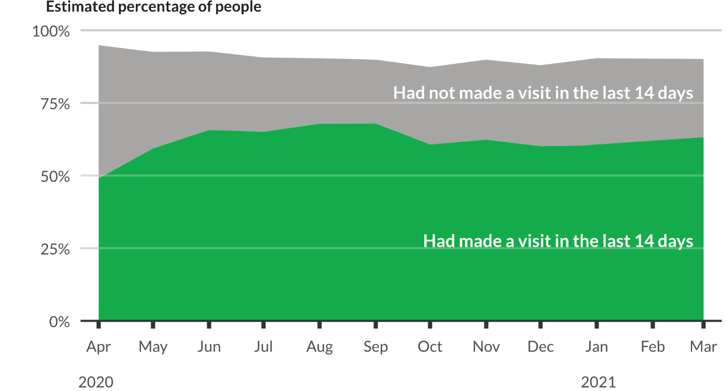

*This visualisation was inspired by a* [*figure*](https://assets.publishing.service.gov.uk/government/uploads/system/uploads/image_data/file/132050/fig1.png) *produced by Natural England.*

The figure below focuses down on just those people who had visited in the last 14 days. This emphasises the increase in people visiting over the spring and summer, before falling back over the Autumn and Winter. The falling back perhaps reflects a combination of seasonal affects and increasing Covid-19 restrictions. Focusing down, also provides the opportunity to acknowledge and show the uncertainty around population estimates based on the survey results (95% confidence intervals are shown in light green).

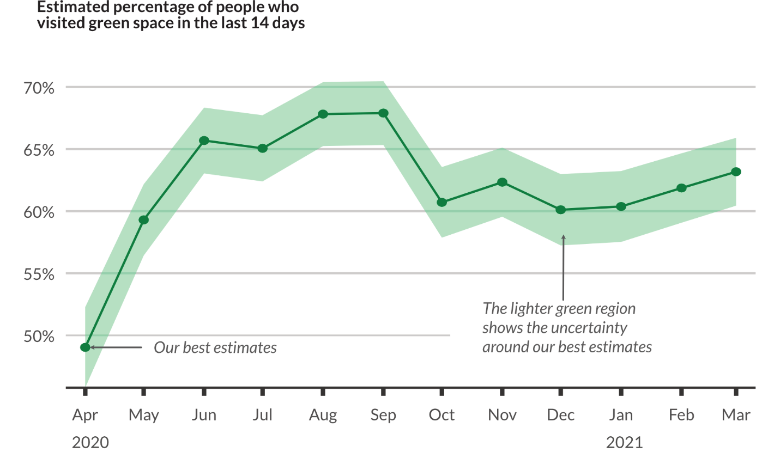

*This visualisation was inspired by a* [*figure*](https://assets.publishing.service.gov.uk/government/uploads/system/uploads/image_data/file/132050/fig1.png) *produced by Natural England.*

If more details of these results is of interest, then take a look at the table below. Otherwise, just skip on to the next part of the data-story.

*This table was inspired by a* [*figure*](https://assets.publishing.service.gov.uk/government/uploads/system/uploads/image_data/file/132050/fig1.png) *produced by Natural England.*

Since the beginning of the pandemic the People and Nature Survey has been asking a series of questions about Covid-19. Some of this data can help us to understand the trends described above. In particular, the survey asked people about their reasons for not spending time outdoors over the last 14 days. In the figure below, we can see the role played by Covid-19 restrictions and concerns over the year.

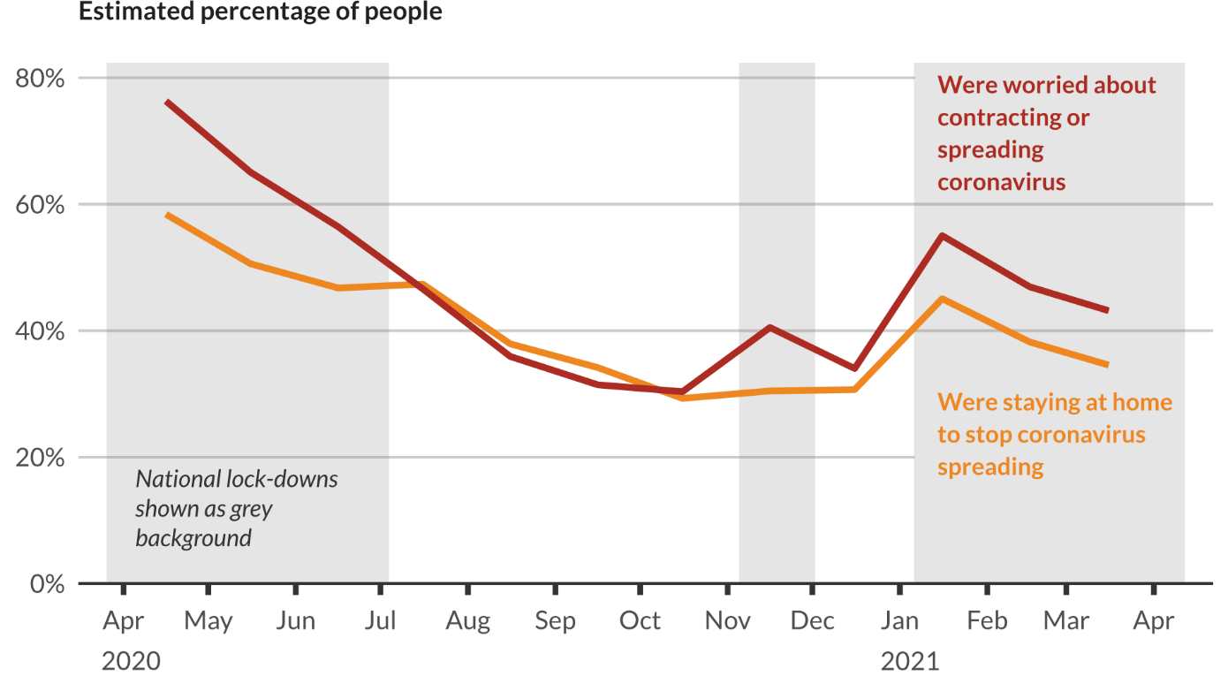

*This visualisation was inspired by a* [*figure*](https://assets.publishing.service.gov.uk/government/uploads/system/uploads/image_data/file/132052/fig3.png) *produced by Natural England.*

In the figure below, for three months, from April to June 2020, we see falling fear of Covid-19 correlated with more people visiting green space. After that, the relationship between the percentage of people citing fear of Covid-19 as a reason not to spend time outdoors, and the percentage of people visiting green spaces, is more complex.

So, the pandemic, and associated restrictions, have contributed to some people’s reluctance to spend time outdoors. In parallel considerable numbers of people have been engaging more with the environment during the pandemic too. The figure below shows these levels of increased engagement were sustained between April 2020 and March 2020.

*This visualisation was inspired by a* [*figure*](https://assets.publishing.service.gov.uk/government/uploads/system/uploads/image_data/file/132052/fig3.png) *produced by Natural England.*

### Other data

#### Values

Many of survey participants agreed (82 or 83%) with a series of statements about nature having value to them (shown in blue in the figure below). However, less participants agreed (58%) with a statement about how connected with nature they feel (“I feel part of nature”, shown in green below). So, there is some evidence of a gap between how many people value nature and how many feel actually connected to nature.

*This visualisation was inspired by a* [*figure*](https://assets.publishing.service.gov.uk/government/uploads/system/uploads/image_data/file/132054/fig5.png) *produced by Natural England.*

***Opportunities for further research:*** The gap identified above is something that researchers could explored further through analysis of the survey data and new qualitative research.

We have seen that only 58% of survey participants could agree with the statement “I feel part of nature”. That leaves a lot of survey participants (42%) who either disagree with or were not sure about the statement. I wondered if perhaps it is difficult to feel part of nature without spending some time in natural and green spaces. So, next I turn to the survey results focused on how often people visits to green spaces.

#### Demographics

Looking beyond the pandemic, there are some interesting relationship between age and frequency of visiting green spaces. The figure below shows that the percentage of people who have not visited green space in the last 14 days increases with age.

*This visualisation was inspired by a* [*figure*](https://assets.publishing.service.gov.uk/government/uploads/system/uploads/image_data/file/132051/fig2.png) *produced by Natural England.*

However, older age groups (specifically those 40 or older) are more likely to visit green spaces very frequently.

*This visualisation was inspired by a* [*figure*](https://assets.publishing.service.gov.uk/government/uploads/system/uploads/image_data/file/132051/fig2.png) *produced by Natural England.*

#### Perceptions

Data from the People and Nature survey can also understand the relationship between inequality and green space. Survey respondents were asked if they perceived the quality of their local green spaces had improved or reduced over the last five years. Respondents with higher household incomes were more likely to perceive improvements in quality. It is worth noting that across all income bands many respondents provided a neutral response (indicating no perceived change in quality).

*This visualisation was inspired by a* [*figure*](https://assets.publishing.service.gov.uk/government/uploads/system/uploads/image_data/file/132053/fig4.png) *produced by Natural England.*

#### Behaviours

The results above show that many people value nature and enjoy visiting natural spaces. The data collected in the People and Nature survey can also addresses the question of what are people doing to protect nature. In the figure below we can see large proportions of people are not frequently engaging in high environmental impact activities (fly and commuting by car). However, eating meat remains a high impact activity that many people engage in regularly.

1. Natural England are a public sector organisation responsible for:

   * protecting and enhancing the natural environment;

   and, promoting people’s connection with the natural environment.